ECE198 DESIGN REVISIONS

Initial design:

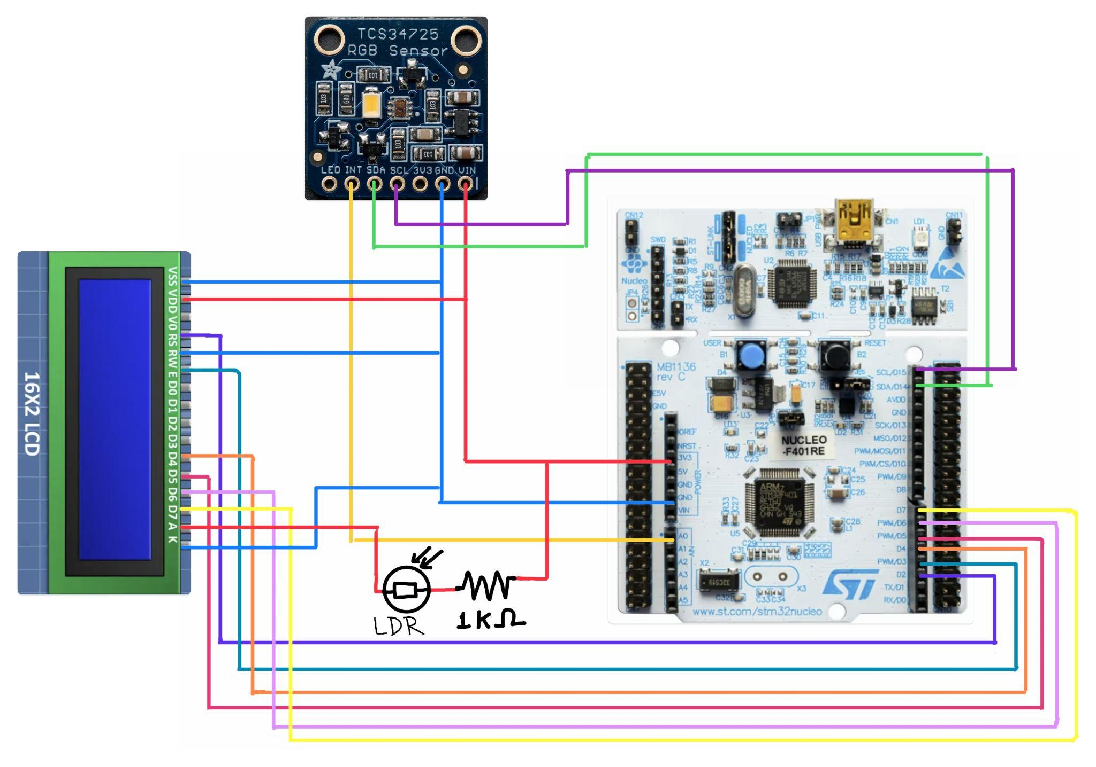

Design revision 1: Nov 4: System Architect Drawing: (lcd → oled)

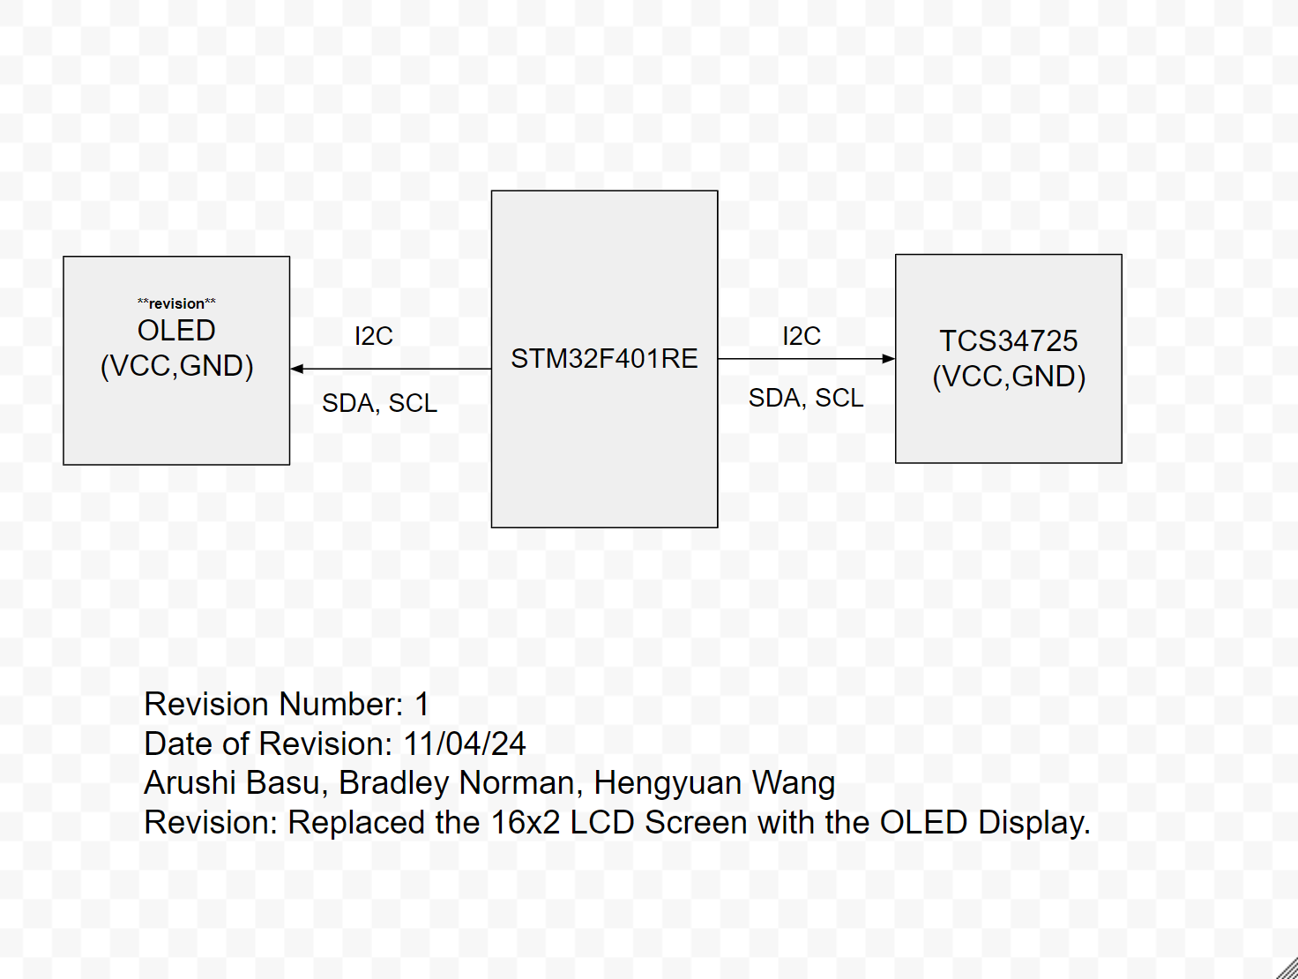

Design revision 2: Nov 13: System Architect Drawing (laser)

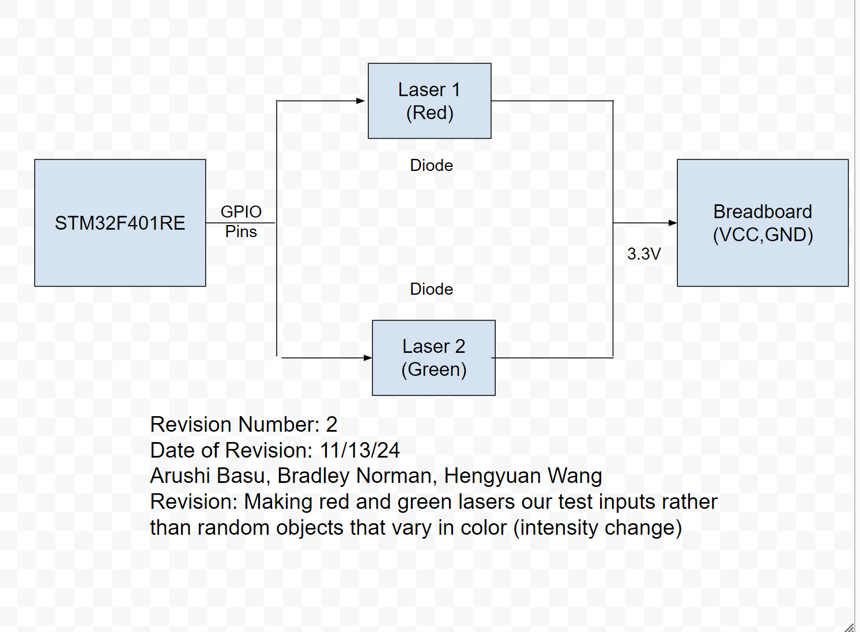

Design revision 3: Nov 15: Electrical Schematic: OLED

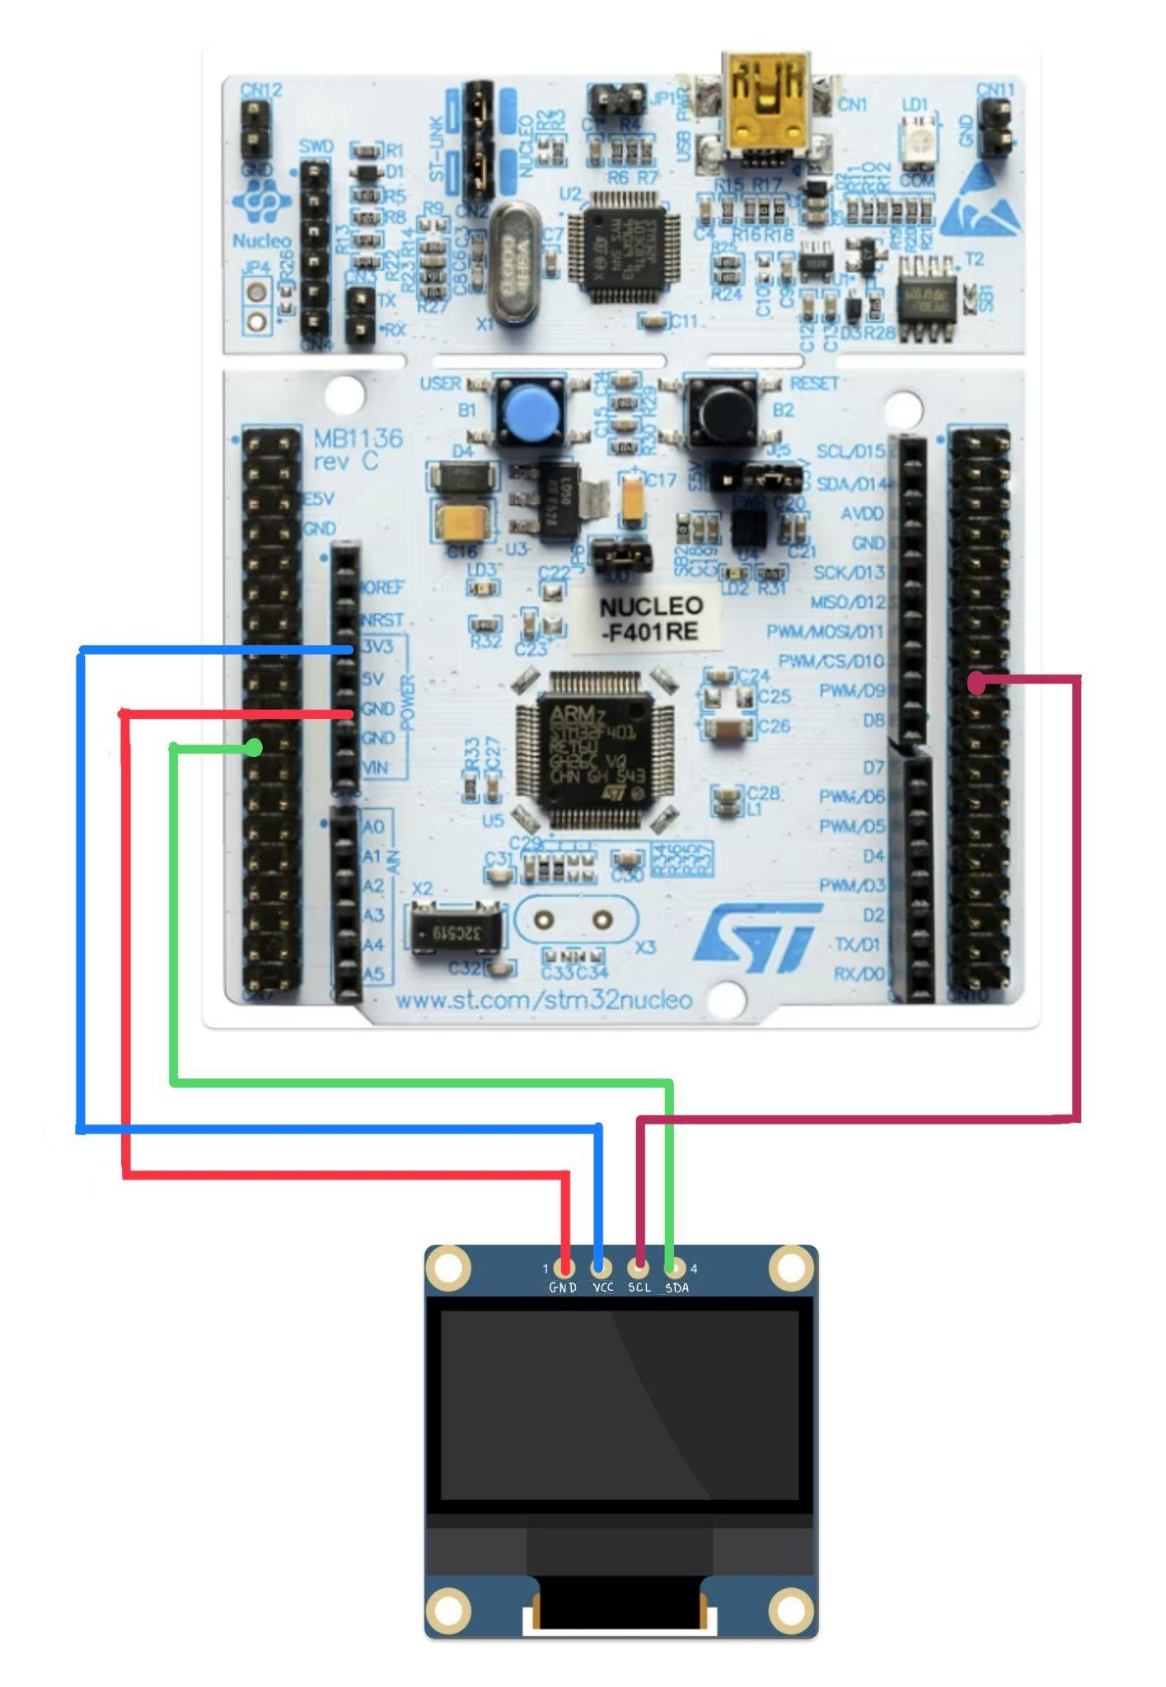

* Previously, the design was implemented using an LCD 16X02 display. The final design uses an 0.96 OLED with connections that look like this.

Design revision 4: Nov 15: Electrical Schematic: TCS34725 Color Sensor

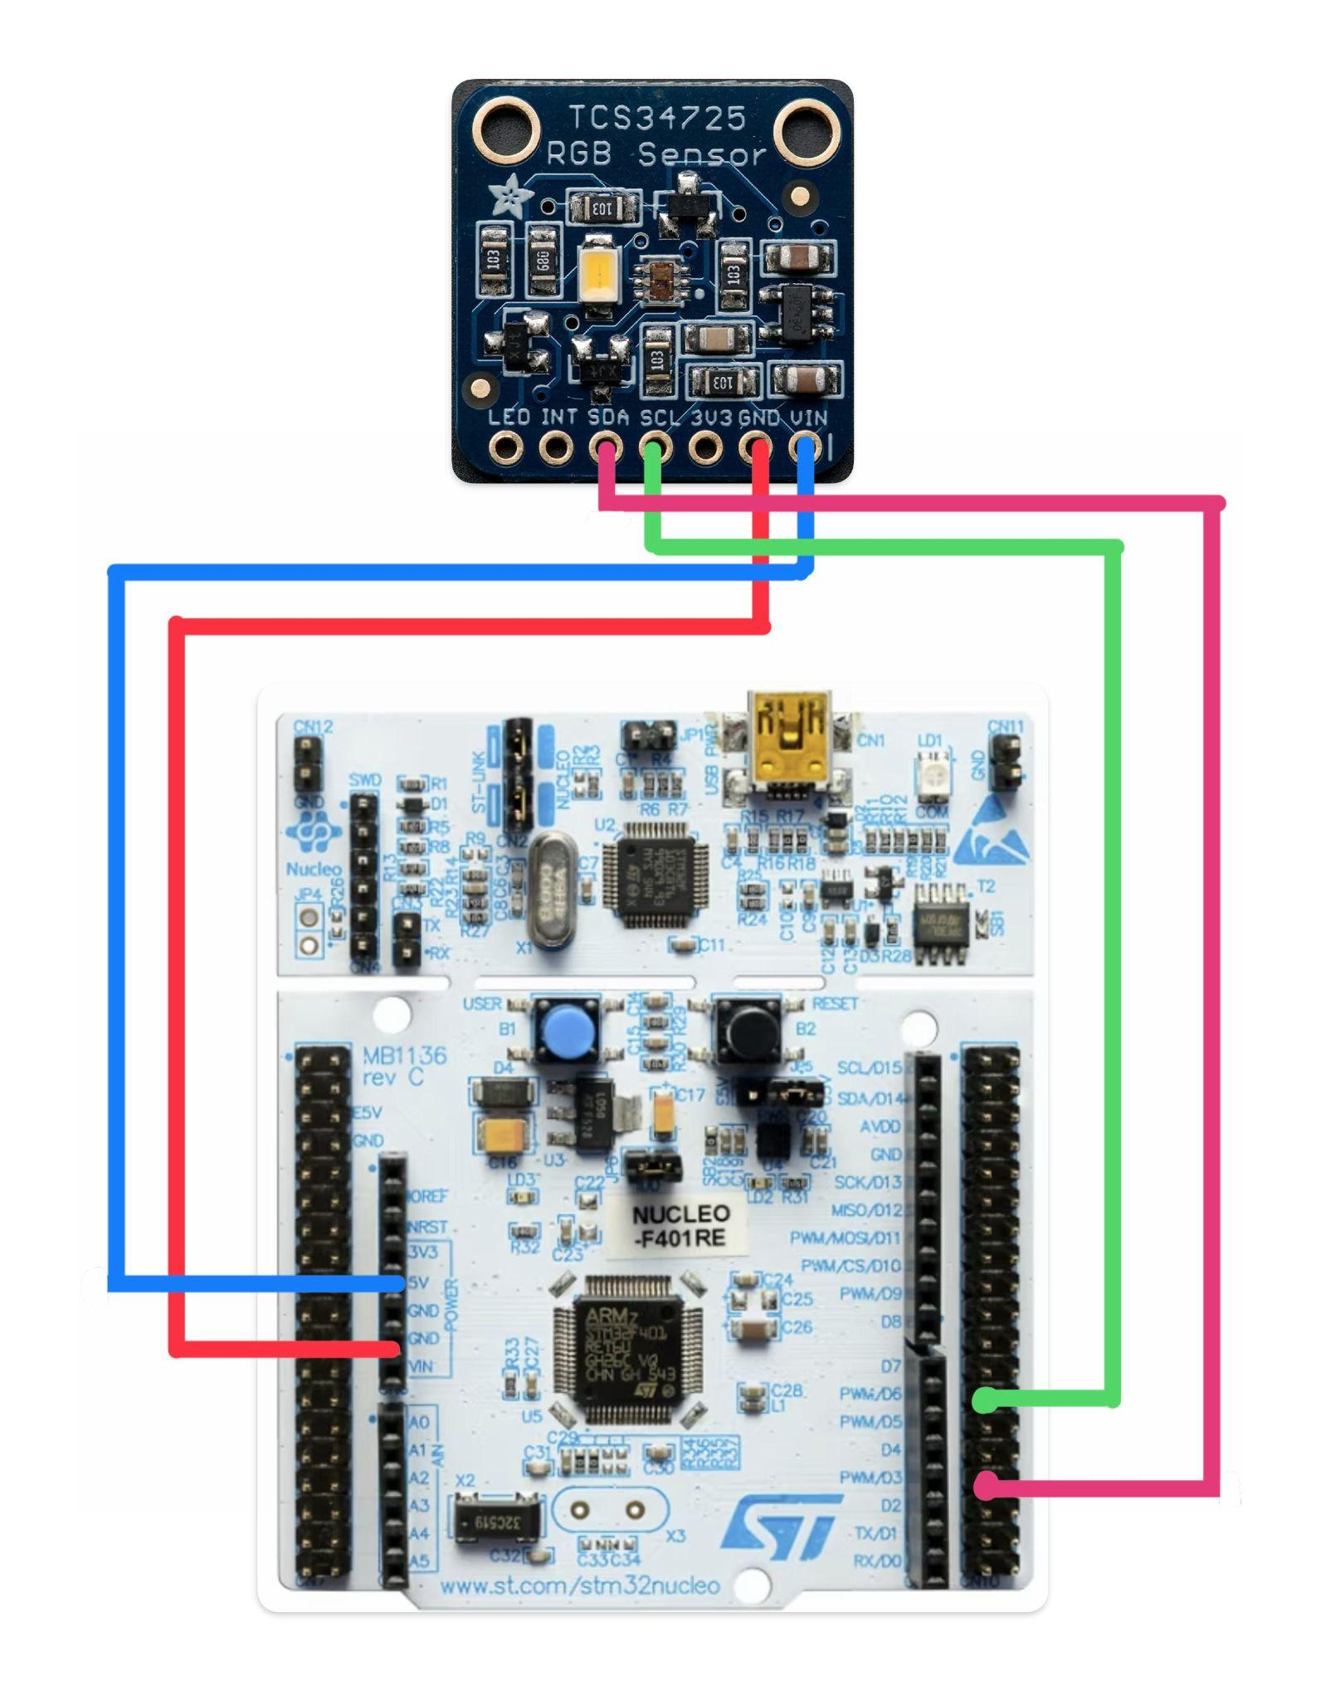

* The wiring from the microcontroller to the color sensor was simplified to this schematic. Previously, it was complicated and it turned out we didn’t need the INT connection of the color sensor.

Design revision 5: Nov 21: Electrical Schematic: Transistor

* Used transistors as a switch for lasers in order to have uniform distribution of voltage to keep the intensity constant.

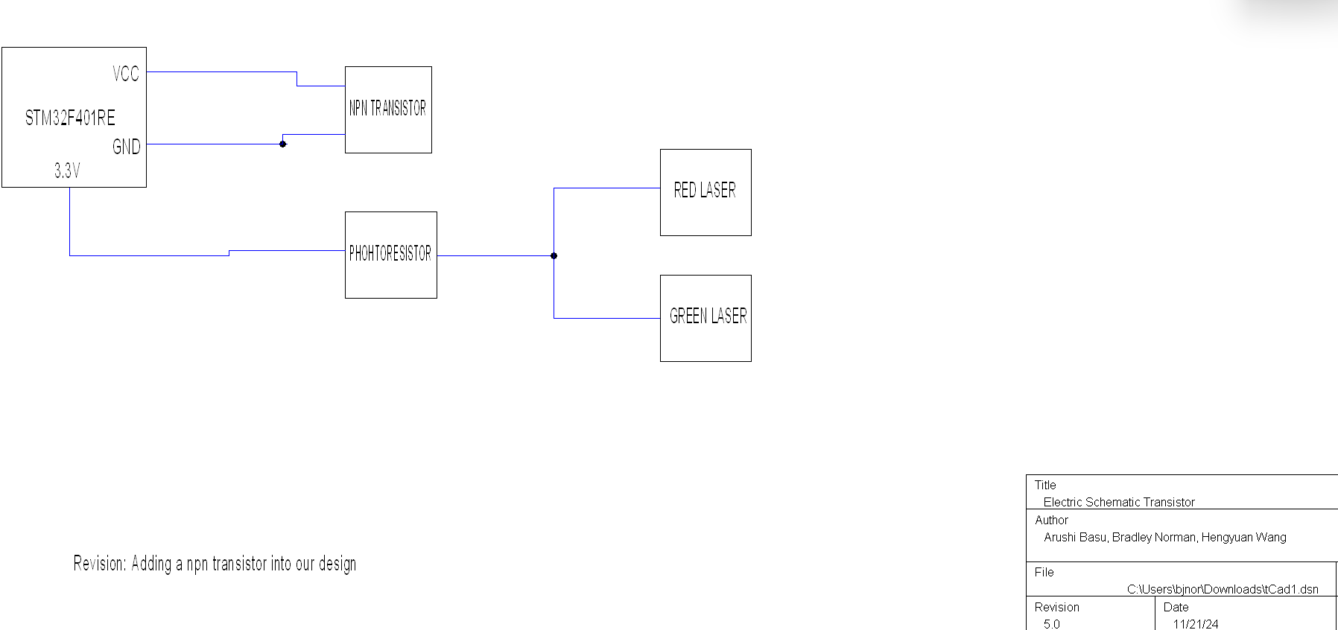

Design revision 6: Nov 23: Electrical Schematic: No resistor used

* The photoresistor was reducing the intensity of light, therefore we decided to remove it from the final design.

